Lecture 08 — Interaction Diagrams
Prepared by Sandaruwani Pathirage
Interaction diagrams are UML behavioral diagrams that illustrate how objects or actors interact with one another by exchanging messages to accomplish a specific task or achieve a particular goal in a system.
Purpose of Interaction Diagrams
- Represent the communication between objects in a system.
- Show the sequence and flow of messages exchanged between objects.
- Describe how objects collaborate to perform a particular operation or use case.
- Help developers understand and design the dynamic behavior of a system.

Communication Diagram | Sequence Diagram
- Focuses on how objects are connected.  - Objects are arranged freely across the diagram.  - Links show relationships between communicating objects.  - Message numbers indicate the order of interactions.  - Emphasizes the organization of objects and their relationships. | - Focuses on when messages occur.  - Objects are arranged horizontally.  - Lifelines extend vertically.  - Messages are ordered from top to bottom.  - Emphasizes the timing and order of interactions.

Communication Diagram
1. What is a Communication Diagram?
A UML Communication Diagram is an interaction diagram that illustrates how objects communicate with each other through messages to perform a particular task or achieve a specific goal.
2. Purpose of a Communication Diagram
- Shows interactions between objects in a system.
- Illustrates the relationships between communicating objects.
- Represents the messages exchanged between objects.
- Helps understand the collaboration between objects to complete a use case.

3. Main Elements
1. Objects
Represent the participants involved in the interaction. Objects are usually shown as rectangles labelled objectName:ClassName.
2. Links
Lines connecting objects to indicate that they can communicate with each other.

3. Messages
Labels on links that represent communication between objects. Messages may represent method calls, requests, or responses.
4. Sequence Numbers
Indicate the order in which messages are sent and processed, such as 1, 2, 2.1, and 2.2.

4. Message Numbering
Messages are numbered to show their execution order.
For example:
- 1: login() – First message.
- 2: validateUser() – Second message.
- 2.1: checkCredentials() – A nested message within message 2.
- 3: displayResult() – Third message.

Example: User Login System
Consider a user logging into a system.
- User → Login Page: enterCredentials()
- Login Page → Database: validateCredentials()
- Database → Login Page: validationResult()
- Login Page → User: displayMessage()

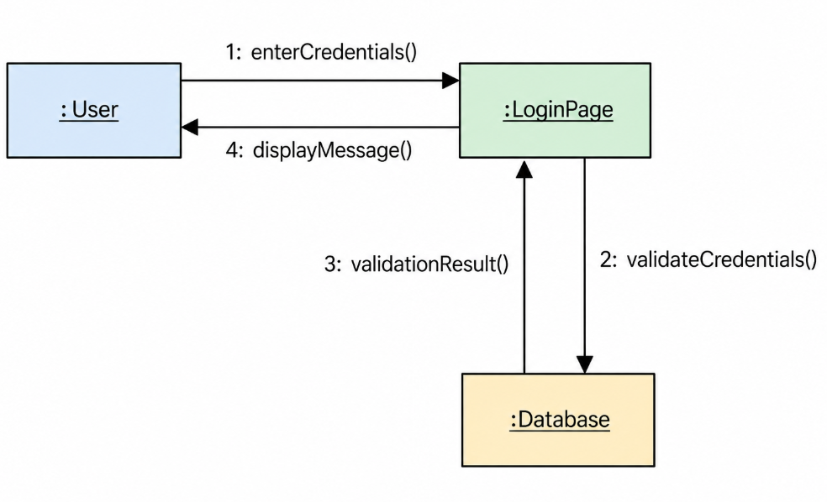

Activity 1: ATM Cash Withdrawal
A customer uses an ATM to withdraw money. The customer inserts their ATM card and enters the PIN. The ATM sends the card details and PIN to the bank system for verification. If the details are valid, the customer enters the withdrawal amount. The bank system checks the account balance and approves the transaction if sufficient funds are available. The ATM dispenses the cash and updates the account balance.
Draw a UML Communication Diagram to represent this scenario.

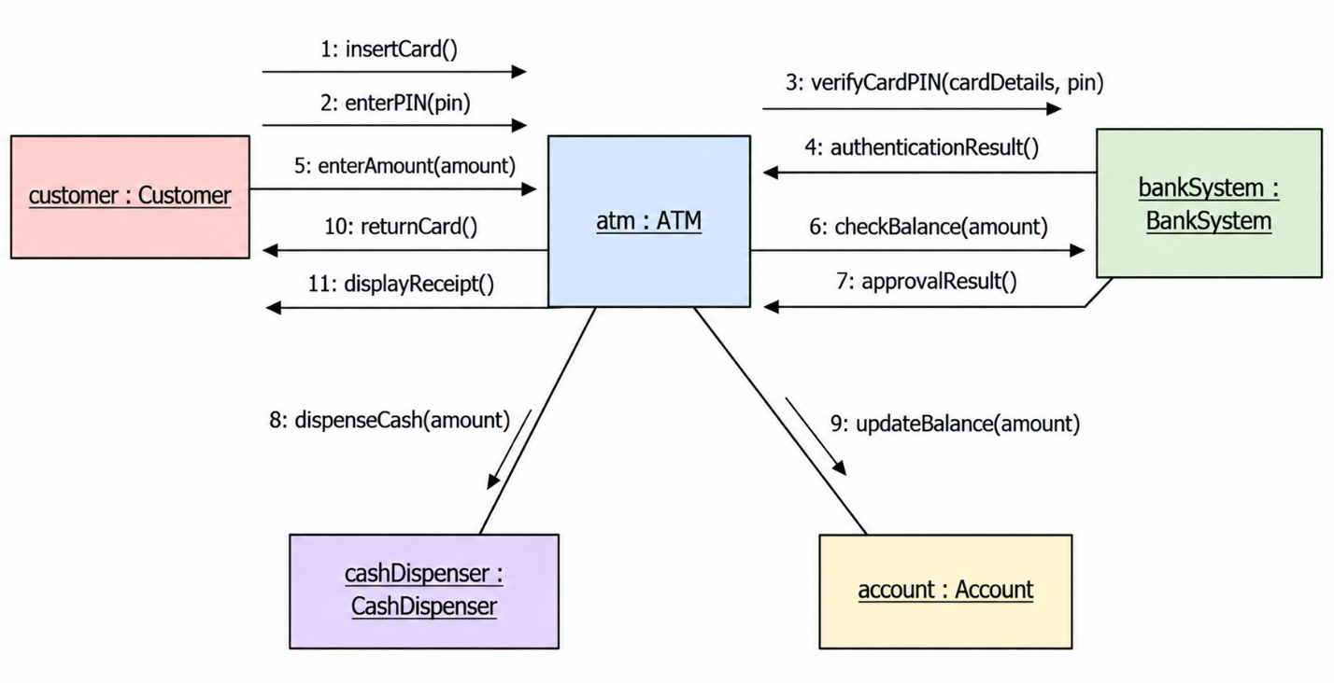

Activity 2: Online Shopping System
A customer visits an online shopping website and searches for a product. The customer selects a product and adds it to the shopping cart. The system checks the product's availability and displays the price. The customer proceeds to checkout and enters delivery details. The payment system processes the payment and sends the payment result to the website. If the payment is successful, the system creates the order and sends an order confirmation to the customer.
Draw a UML Communication Diagram to represent this scenario.

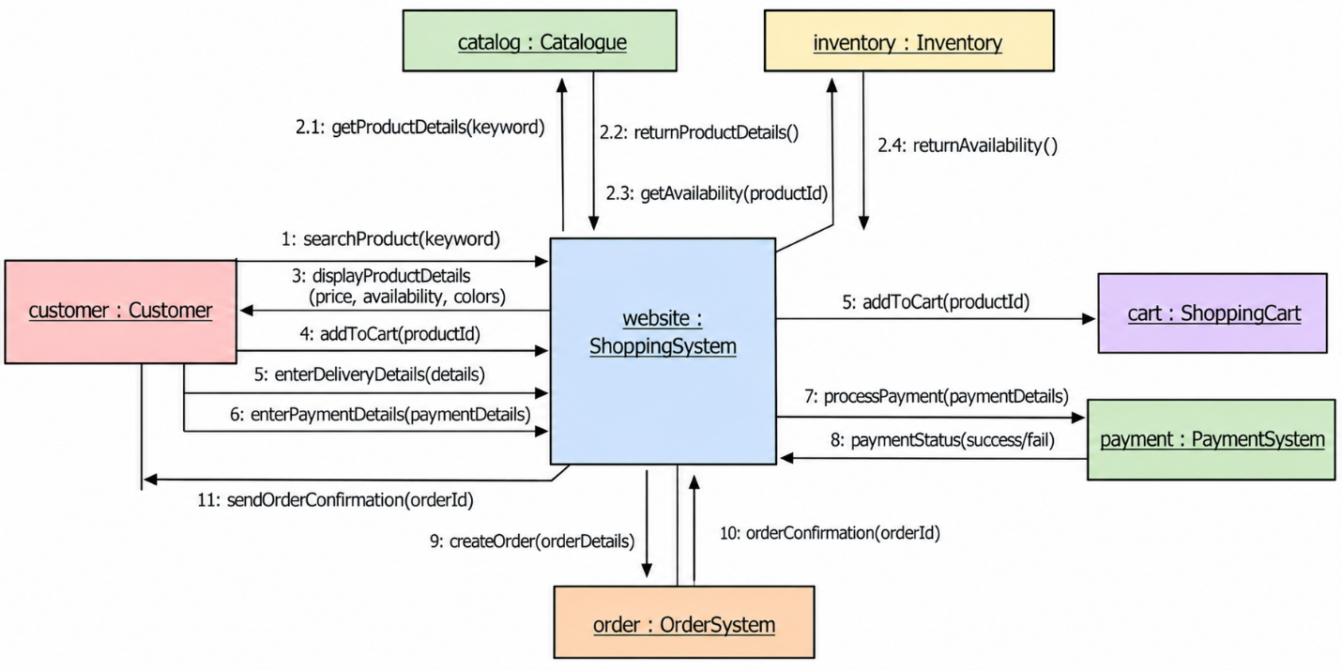

Activity 3: Library Book Borrowing System
A student requests to borrow a book from a library. The Student object sends a borrowing request to the LibrarySystem object. The LibrarySystem checks whether the requested book is available. If the book is available, the system updates the borrowing record and confirms the borrowing request to the student. Before confirming, the LibrarySystem calculates the due date for returning the book by performing an internal operation.

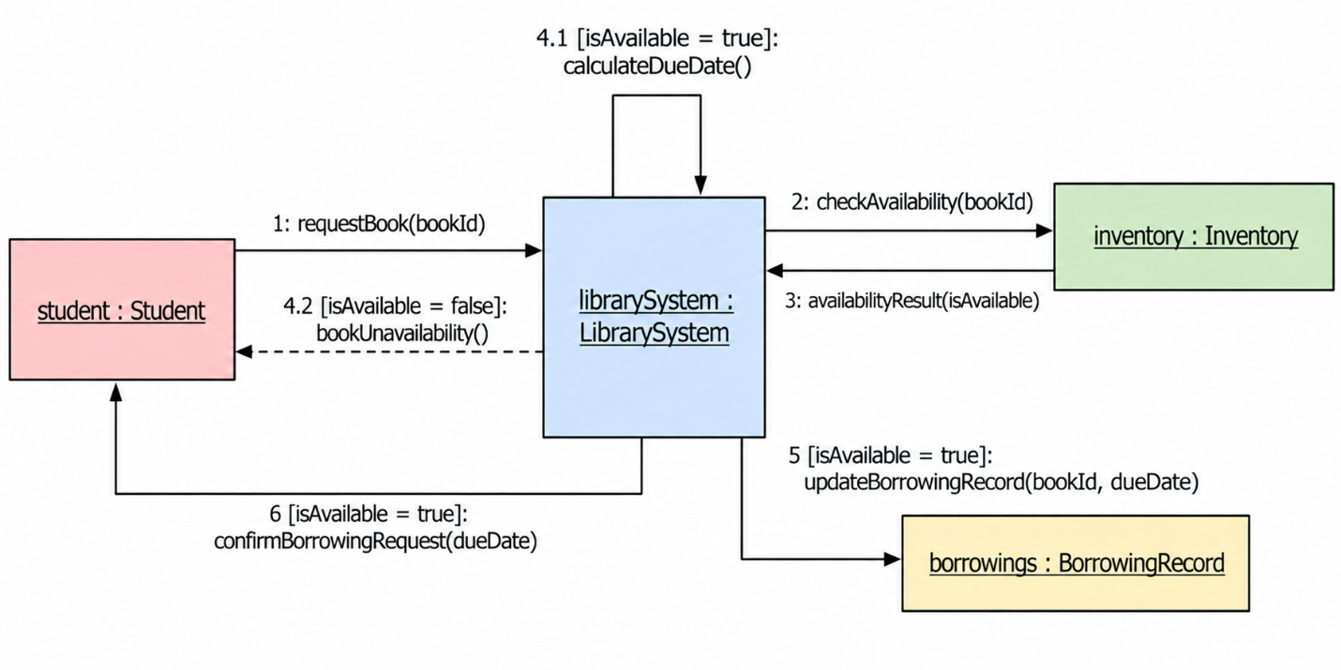

Activity 4: ATM PIN Verification with Repetition
A customer inserts an ATM card and enters a PIN. The ATM system sends the PIN to the bank system for verification. If the PIN is incorrect, the ATM asks the customer to re-enter the PIN. This process repeats until the customer enters the correct PIN or reaches the maximum of three attempts. If the PIN is correct, the ATM displays the transaction menu; otherwise, after three incorrect attempts, the ATM retains the card and displays a message.
Draw a UML Communication Diagram to represent this scenario.

